Use Case Diagram

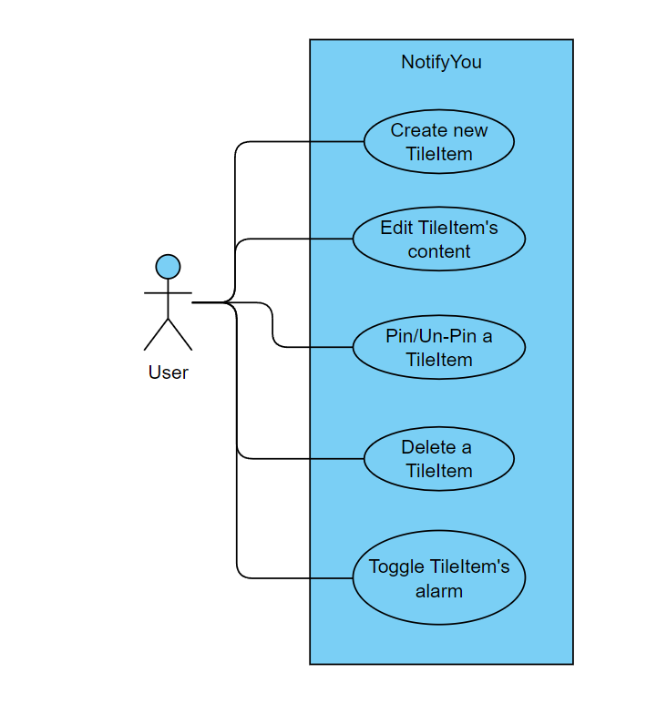

Class Diagram



Activity Diagram – New TileItem



Activity Diagram – Toggle Alarm

Activity Diagram – Trigger Alarm

Activity Diagram – Toggle Alarm



Activity Diagram – Delete TileItem

